BMV:BIMBO A Mex$ NA Mex$ NA (MI KEY: 4276592; SPCIQ KEY: 877906)
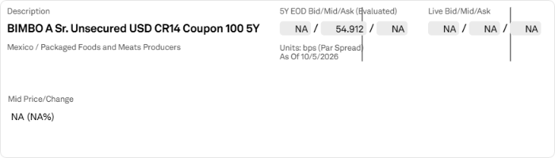
CDS Curves
Applied Filters:
Compare :
Display : Par Spread Mid
Attribute : SNRFOR USD CR14
Time Period : 1M,3M
Coupon : 100
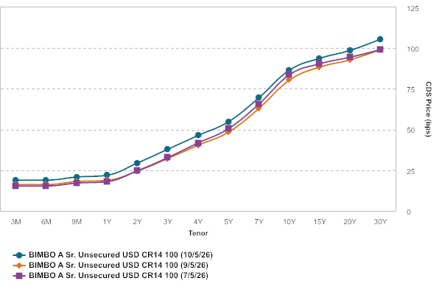
Issuer Name | Curve Description | Curve Date | 3M | 6M | 9M | 1Y | 2Y | 3Y | 4Y | 5Y | 7Y | 10Y | 15Y | 20Y | 30Y
Grupo Bimbo, S.A.B. de C.V. | BIMBO A Sr. Unsecured USD CR14 100 | 10/5/2026 | 18.981 | 18.982 | 20.906 | 22.019 | 29.509 | 37.981 | 46.465 | 54.912 | 69.615 | 86.500 | 93.780 | 98.663 | 105.572
Grupo Bimbo, S.A.B. de C.V. | BIMBO A Sr. Unsecured USD CR14 100 | 9/5/2026 | 16.258 | 16.234 | 18.134 | 18.853 | 24.566 | 32.313 | 40.413 | 48.524 | 63.037 | 80.409 | 88.387 | 92.895 | 99.136
Grupo Bimbo, S.A.B. de C.V. | BIMBO A Sr. Unsecured USD CR14 100 | 7/5/2026 | 15.394 | 15.392 | 17.166 | 18.041 | 24.784 | 32.874 | 41.856 | 50.662 | 65.745 | 83.673 | 90.450 | 94.479 | 99.079

CDS Chart
Applied Filters:
Compare :
Tenor : 5Y
Display : Par Spread Mid
Attribute : SNRFOR USD CR14
Graph Type : CDS Price
Coupon : 100
Days : 1Y
Date : 10/5/2025 To 10/5/2026
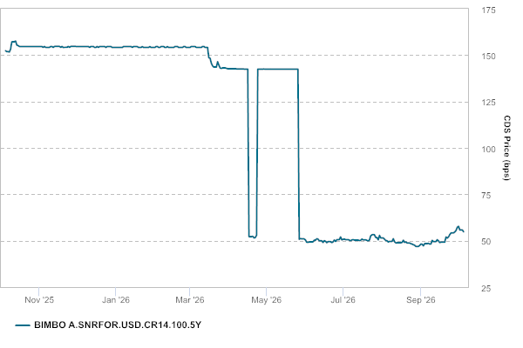
Pricing Date | BIMBO A.SNRFOR.USD.CR14.100.5Y | BIMBO A.SNRFOR.USD.CR14.100.5Y Method
10/5/2026 | 54.912 | Evaluated
10/4/2026 | 55.873 | Evaluated
10/3/2026 | 55.873 | Evaluated
10/2/2026 | 55.873 | Evaluated
10/1/2026 | 57.848 | Evaluated
9/30/2026 | 57.308 | Evaluated
9/29/2026 | 55.606 | Evaluated
9/28/2026 | 54.784 | Evaluated
9/27/2026 | 54.267 | Evaluated
9/26/2026 | 54.267 | Evaluated
9/25/2026 | 54.267 | Evaluated
9/24/2026 | 53.337 | Evaluated
9/23/2026 | 52.123 | Evaluated
9/22/2026 | 51.462 | Evaluated
9/21/2026 | 52.097 | Evaluated
9/20/2026 | 49.336 | Evaluated
9/19/2026 | 49.336 | Evaluated
9/18/2026 | 49.336 | Evaluated
9/17/2026 | 49.268 | Evaluated
9/16/2026 | 49.059 | Evaluated
9/15/2026 | 49.979 | Evaluated
9/14/2026 | 50.609 | Evaluated
9/13/2026 | 49.598 | Evaluated
9/12/2026 | 49.598 | Evaluated
9/11/2026 | 49.598 | Evaluated
9/10/2026 | 50.261 | Evaluated
9/9/2026 | 48.306 | Evaluated
9/8/2026 | 48.291 | Evaluated
9/7/2026 | 48.616 | Evaluated
9/6/2026 | 48.524 | Evaluated
9/5/2026 | 48.524 | Evaluated
9/4/2026 | 48.524 | Evaluated
9/3/2026 | 47.284 | Evaluated
9/2/2026 | 48.137 | Evaluated
9/1/2026 | 48.278 | Evaluated
8/31/2026 | 47.472 | Evaluated
8/30/2026 | 46.990 | Evaluated
8/29/2026 | 46.990 | Evaluated
8/28/2026 | 46.990 | Evaluated
8/27/2026 | 47.627 | Evaluated
8/26/2026 | 47.900 | Evaluated
8/25/2026 | 48.259 | Evaluated
8/24/2026 | 48.481 | Evaluated
8/23/2026 | 48.819 | Evaluated
8/22/2026 | 48.819 | Evaluated
8/21/2026 | 48.819 | Evaluated
8/20/2026 | 49.430 | Evaluated
8/19/2026 | 49.122 | Evaluated
8/18/2026 | 50.368 | Evaluated
8/17/2026 | 49.162 | Evaluated
8/16/2026 | 48.933 | Evaluated
8/15/2026 | 48.933 | Evaluated
8/14/2026 | 48.933 | Evaluated
8/13/2026 | 48.947 | Evaluated
8/12/2026 | 48.901 | Evaluated
8/11/2026 | 49.507 | Evaluated
8/10/2026 | 51.172 | Evaluated
8/9/2026 | 49.719 | Evaluated
8/8/2026 | 49.719 | Evaluated
8/7/2026 | 49.719 | Evaluated
8/6/2026 | 49.377 | Evaluated
8/5/2026 | 50.065 | Evaluated
8/4/2026 | 50.165 | Evaluated
8/3/2026 | 50.906 | Evaluated
8/2/2026 | 51.575 | Evaluated
8/1/2026 | 51.575 | Evaluated
7/31/2026 | 51.575 | Evaluated
7/30/2026 | 52.935 | Evaluated
7/29/2026 | 50.517 | Evaluated
7/28/2026 | 51.732 | Evaluated
7/27/2026 | 51.804 | Evaluated
7/26/2026 | 53.254 | Evaluated
7/25/2026 | 53.254 | Evaluated
7/24/2026 | 53.254 | Evaluated
7/23/2026 | 52.693 | Evaluated
7/22/2026 | 50.428 | Evaluated
7/21/2026 | 49.919 | Evaluated
7/20/2026 | 50.275 | Evaluated
7/19/2026 | 50.518 | Evaluated
7/18/2026 | 50.518 | Evaluated
7/17/2026 | 50.518 | Evaluated
7/16/2026 | 50.909 | Evaluated
7/15/2026 | 50.301 | Evaluated
7/14/2026 | 50.109 | Evaluated
7/13/2026 | 50.412 | Evaluated
7/12/2026 | 50.376 | Evaluated
7/11/2026 | 50.376 | Evaluated
7/10/2026 | 50.376 | Evaluated
7/9/2026 | 50.632 | Evaluated
7/8/2026 | 50.493 | Evaluated
7/7/2026 | 50.058 | Evaluated
7/6/2026 | 50.350 | Evaluated
7/5/2026 | 50.662 | Evaluated
7/4/2026 | 50.662 | Evaluated
7/3/2026 | 50.662 | Evaluated
7/2/2026 | 50.940 | Evaluated
7/1/2026 | 50.820 | Evaluated
6/30/2026 | 50.500 | Evaluated
6/29/2026 | 52.146 | Evaluated
6/28/2026 | 50.656 | Evaluated
6/27/2026 | 50.656 | Evaluated
6/26/2026 | 50.656 | Evaluated
6/25/2026 | 49.686 | Evaluated
6/24/2026 | 50.429 | Evaluated
6/23/2026 | 49.396 | Evaluated
6/22/2026 | 49.036 | Evaluated
6/21/2026 | 49.555 | Evaluated
6/20/2026 | 49.555 | Evaluated
6/19/2026 | 49.555 | Evaluated
6/18/2026 | 49.004 | Evaluated
6/17/2026 | 49.743 | Evaluated
6/16/2026 | 50.077 | Evaluated
6/15/2026 | 49.089 | Evaluated
6/14/2026 | 50.035 | Evaluated
6/13/2026 | 50.035 | Evaluated
6/12/2026 | 50.035 | Evaluated
6/11/2026 | 50.906 | Evaluated
6/10/2026 | 51.153 | Evaluated
6/9/2026 | 50.325 | Evaluated
6/8/2026 | 50.336 | Evaluated
6/7/2026 | 49.434 | Evaluated
6/6/2026 | 49.434 | Evaluated
6/5/2026 | 49.434 | Evaluated
6/4/2026 | 49.395 | Evaluated
6/3/2026 | 49.170 | Evaluated
6/2/2026 | 49.233 | Evaluated
6/1/2026 | 50.449 | Evaluated
5/31/2026 | 51.042 | Evaluated
5/30/2026 | 51.042 | Evaluated
5/29/2026 | 51.042 | Evaluated
5/28/2026 | 51.273 | Evaluated
5/27/2026 | 50.837 | Evaluated
5/26/2026 | 142.481 | Composite
5/25/2026 | 142.518 | Composite
5/24/2026 | 142.526 | Composite
5/23/2026 | 142.526 | Composite
5/22/2026 | 142.526 | Composite
5/21/2026 | 142.487 | Composite
5/20/2026 | 142.473 | Composite
5/19/2026 | 142.527 | Composite
5/18/2026 | 142.497 | Composite
5/17/2026 | 142.536 | Composite
5/16/2026 | 142.536 | Composite
5/15/2026 | 142.536 | Composite
5/14/2026 | 142.500 | Composite
5/13/2026 | 142.486 | Composite
5/12/2026 | 142.493 | Composite
5/11/2026 | 142.518 | Composite
5/10/2026 | 142.479 | Composite
5/9/2026 | 142.479 | Composite
5/8/2026 | 142.479 | Composite
5/7/2026 | 142.499 | Composite
5/6/2026 | 142.466 | Composite
5/5/2026 | 142.495 | Composite
5/4/2026 | 142.546 | Composite
5/3/2026 | 142.495 | Composite
5/2/2026 | 142.495 | Composite
5/1/2026 | 142.495 | Composite
4/30/2026 | 142.491 | Composite
4/29/2026 | 142.570 | Composite
4/28/2026 | 142.520 | Composite
4/27/2026 | 142.539 | Composite
4/26/2026 | 142.507 | Composite
4/25/2026 | 142.507 | Composite
4/24/2026 | 142.507 | Composite
4/23/2026 | 52.981 | Evaluated
4/22/2026 | 51.767 | Evaluated
4/21/2026 | 51.557 | Evaluated
4/20/2026 | 52.460 | Evaluated
4/19/2026 | 52.288 | Evaluated
4/18/2026 | 52.288 | Evaluated
4/17/2026 | 52.288 | Evaluated
4/16/2026 | 142.531 | Composite
4/15/2026 | 142.528 | Composite
4/14/2026 | 142.496 | Composite
4/13/2026 | 142.539 | Composite
4/12/2026 | 142.570 | Composite
4/11/2026 | 142.570 | Composite
4/10/2026 | 142.570 | Composite
4/9/2026 | 142.585 | Composite
4/8/2026 | 142.641 | Composite
4/7/2026 | 142.666 | Composite
4/6/2026 | 142.708 | Composite
4/5/2026 | 142.745 | Composite
4/4/2026 | 142.745 | Composite
4/3/2026 | 142.745 | Composite
4/2/2026 | 142.751 | Composite
4/1/2026 | 142.715 | Composite
3/31/2026 | 142.737 | Composite
3/30/2026 | 142.940 | Composite
3/29/2026 | 143.209 | Composite
3/28/2026 | 143.209 | Composite
3/27/2026 | 143.209 | Composite
3/26/2026 | 142.887 | Composite
3/25/2026 | 143.107 | Composite
3/24/2026 | 144.652 | Composite
3/23/2026 | 146.486 | Composite
3/22/2026 | 143.605 | Composite
3/21/2026 | 143.605 | Composite
3/20/2026 | 143.605 | Composite
3/19/2026 | 144.216 | Composite
3/18/2026 | 145.652 | Composite
3/17/2026 | 148.398 | Composite
3/16/2026 | 148.653 | Composite
3/15/2026 | 154.197 | Composite
3/14/2026 | 154.197 | Composite
3/13/2026 | 154.197 | Composite
3/12/2026 | 154.743 | Composite
3/11/2026 | 154.711 | Composite
3/10/2026 | 154.206 | Composite
3/9/2026 | 154.214 | Composite
3/8/2026 | 154.233 | Composite
3/7/2026 | 154.233 | Composite
3/6/2026 | 154.233 | Composite
3/5/2026 | 154.700 | Composite
3/4/2026 | 154.687 | Composite
3/3/2026 | 154.699 | Composite
3/2/2026 | 154.693 | Composite
3/1/2026 | 154.211 | Composite
2/28/2026 | 154.211 | Composite
2/27/2026 | 154.211 | Composite
2/26/2026 | 154.191 | Composite
2/25/2026 | 154.677 | Composite
2/24/2026 | 154.683 | Composite
2/23/2026 | 154.184 | Composite
2/22/2026 | 154.178 | Composite
2/21/2026 | 154.178 | Composite
2/20/2026 | 154.178 | Composite
2/19/2026 | 154.684 | Composite
2/18/2026 | 154.679 | Composite
2/17/2026 | 154.679 | Composite
2/16/2026 | 154.186 | Composite
2/15/2026 | 154.185 | Composite
2/14/2026 | 154.185 | Composite
2/13/2026 | 154.185 | Composite
2/12/2026 | 154.186 | Composite
2/11/2026 | 154.690 | Composite
2/10/2026 | 154.182 | Composite
2/9/2026 | 154.182 | Composite
2/8/2026 | 154.686 | Composite
2/7/2026 | 154.686 | Composite
2/6/2026 | 154.686 | Composite
2/5/2026 | 154.205 | Composite
2/4/2026 | 154.202 | Composite
2/3/2026 | 154.710 | Composite
2/2/2026 | 154.689 | Composite
2/1/2026 | 154.192 | Composite
1/31/2026 | 154.192 | Composite
1/30/2026 | 154.192 | Composite
1/29/2026 | 154.186 | Composite
1/28/2026 | 154.691 | Composite
1/27/2026 | 154.192 | Composite
1/26/2026 | 154.195 | Composite
1/25/2026 | 154.191 | Composite
1/24/2026 | 154.191 | Composite
1/23/2026 | 154.191 | Composite
1/22/2026 | 154.690 | Composite
1/21/2026 | 154.188 | Composite
1/20/2026 | 154.202 | Composite
1/19/2026 | 154.190 | Composite
1/18/2026 | 154.657 | Composite
1/17/2026 | 154.657 | Composite
1/16/2026 | 154.657 | Composite
1/15/2026 | 154.694 | Composite
1/14/2026 | 154.204 | Composite
1/13/2026 | 154.711 | Composite
1/12/2026 | 154.696 | Composite
1/11/2026 | 154.690 | Composite
1/10/2026 | 154.690 | Composite
1/9/2026 | 154.690 | Composite
1/8/2026 | 154.696 | Composite
1/7/2026 | 154.704 | Composite
1/6/2026 | 154.175 | Composite
1/5/2026 | 154.208 | Composite
1/4/2026 | 154.192 | Composite
1/3/2026 | 154.192 | Composite
1/2/2026 | 154.192 | Composite
1/1/2026 | 154.192 | Composite
12/31/2025 | 154.192 | Composite
12/30/2025 | 154.198 | Composite
12/29/2025 | 154.192 | Composite
12/28/2025 | 154.693 | Composite
12/27/2025 | 154.693 | Composite
12/26/2025 | 154.693 | Composite
12/25/2025 | 154.696 | Composite
12/24/2025 | 154.197 | Composite
12/23/2025 | 154.696 | Composite
12/22/2025 | 154.700 | Composite
12/21/2025 | 154.701 | Composite
12/20/2025 | 154.701 | Composite
12/19/2025 | 154.701 | Composite
12/18/2025 | 154.205 | Composite
12/17/2025 | 154.710 | Composite
12/16/2025 | 154.205 | Composite
12/15/2025 | 154.201 | Composite
12/14/2025 | 154.700 | Composite
12/13/2025 | 154.700 | Composite
12/12/2025 | 154.700 | Composite
12/11/2025 | 154.207 | Composite
12/10/2025 | 154.706 | Composite
12/9/2025 | 154.721 | Composite
12/8/2025 | 154.715 | Composite
12/7/2025 | 154.708 | Composite
12/6/2025 | 154.708 | Composite
12/5/2025 | 154.708 | Composite
12/4/2025 | 154.707 | Composite
12/3/2025 | 154.691 | Composite
12/2/2025 | 154.713 | Composite
12/1/2025 | 154.719 | Composite
11/30/2025 | 154.728 | Composite
11/29/2025 | 154.728 | Composite
11/28/2025 | 154.728 | Composite
11/27/2025 | 154.731 | Composite
11/26/2025 | 154.731 | Composite
11/25/2025 | 154.247 | Composite
11/24/2025 | 154.750 | Composite
11/23/2025 | 154.259 | Composite
11/22/2025 | 154.259 | Composite
11/21/2025 | 154.259 | Composite
11/20/2025 | 154.173 | Composite
11/19/2025 | 154.746 | Composite
11/18/2025 | 154.253 | Composite
11/17/2025 | 154.752 | Composite
11/16/2025 | 154.733 | Composite
11/15/2025 | 154.733 | Composite
11/14/2025 | 154.733 | Composite
11/13/2025 | 154.742 | Composite
11/12/2025 | 154.230 | Composite
11/11/2025 | 154.717 | Composite
11/10/2025 | 154.713 | Composite
11/9/2025 | 154.235 | Composite
11/8/2025 | 154.235 | Composite
11/7/2025 | 154.235 | Composite
11/6/2025 | 154.232 | Composite
11/5/2025 | 154.707 | Composite
11/4/2025 | 154.207 | Composite
11/3/2025 | 154.690 | Composite
11/2/2025 | 154.700 | Composite
11/1/2025 | 154.700 | Composite
10/31/2025 | 154.700 | Composite
10/30/2025 | 154.709 | Composite
10/29/2025 | 154.701 | Composite
10/28/2025 | 154.680 | Composite
10/27/2025 | 154.673 | Composite
10/26/2025 | 154.692 | Composite
10/25/2025 | 154.692 | Composite
10/24/2025 | 154.692 | Composite
10/23/2025 | 154.708 | Composite
10/22/2025 | 154.721 | Composite
10/21/2025 | 154.701 | Composite
10/20/2025 | 154.701 | Composite
10/19/2025 | 154.721 | Composite
10/18/2025 | 154.721 | Composite
10/17/2025 | 154.721 | Composite
10/16/2025 | 154.733 | Composite
10/15/2025 | 155.201 | Composite
10/14/2025 | 155.456 | Composite
10/13/2025 | 157.703 | Composite
10/12/2025 | 157.209 | Composite
10/11/2025 | 157.209 | Composite
10/10/2025 | 157.209 | Composite
10/9/2025 | 153.197 | Composite
10/8/2025 | 151.693 | Composite
10/7/2025 | 151.944 | Composite
10/6/2025 | 151.941 | Composite
10/5/2025 | 152.441 | Composite

Securities finance, Credit Default Swap and pricing data may not be used in conjunction with Investment Accounting Activities.

